Key Stage 3 Remote Learning Survey
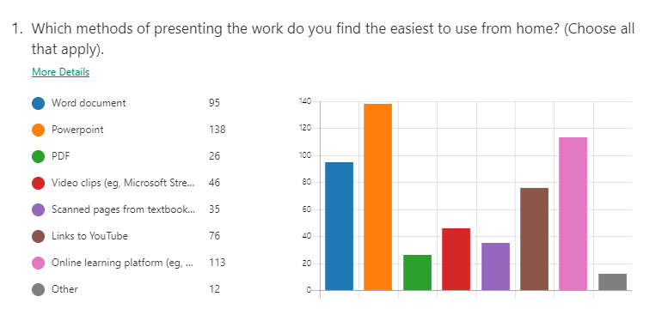

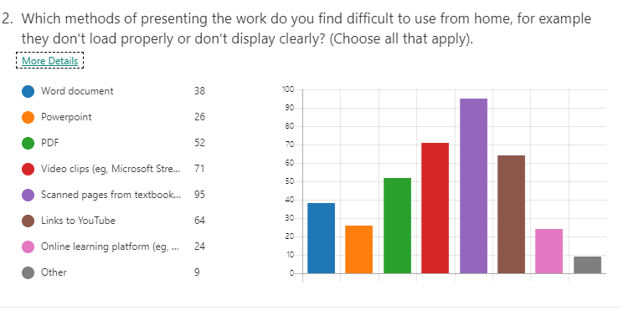

Questions 1 and 2: Which methods of presenting the work do you find easiest/most difficult to use at home (eg, won’t load properly, don’t display clearly)?
- Word documents and PowerPoints are the easiest to use for most students.
- Using scanned pages from textbooks presents significant problems. Comments included them not loading properly, being too small for those relying on phone screens, and being too blurry. Could we investigate online versions of the textbooks or using other resources to deliver the same information?
- PDFs are also a problem for a significant number of students as they simply won’t open.

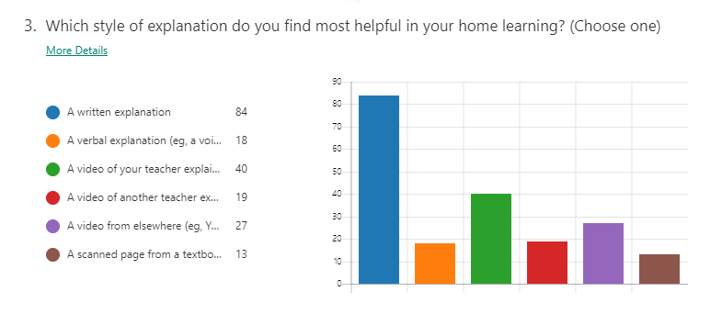Question 3: Which style of explanation do you find the most helpful in your home learning?
- Written explanation was overwhelmingly the most favoured option because students could read at their own pace and refer back to it.
- Students’ second favourite option is a video of the teacher explaining.
- Since this survey, live lessons via Microsoft Teams have also proven very popular with students as they can directly communicate with their teacher as they are working and thus request clarification as soon as they need it.

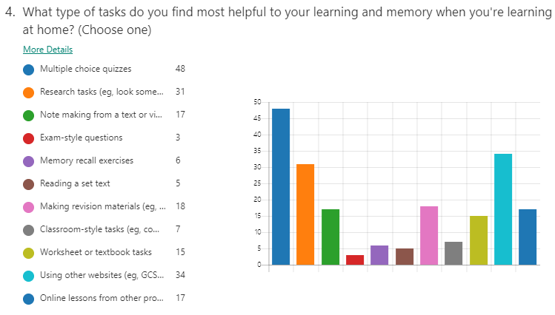
Question 4: What type of tasks do you find most helpful to your learning and memory when you’re working at home?
- Multiple choice quizzes scored very highly here – students commented that they liked the security of knowing one of the answers was right and it helped them to remember what they had just learned.
- Research tasks with note making and making revision materials as they can refer back to it to support their retention in later lessons.
- Students’ least favourite style of task is exam-style questions.

