Priory Belvoir Academy : Reading Strategy
At Belvoir, we have a 5 strand strategy to reading for purpose, and reading for pleasure.
Our expectation is that everyone is a reader and that all of our students can, and do, read for purpose, and for pleasure.
Nevertheless, we understand that you can’t love reading if you can’t read, and that this causes a barrier to curriculum access.

- Motivation, Resilience and Reading for Pleasure

Whole School through the tutor programme, and at home with parental engagement

- Tracking Reading – identification of types of reader, monitoring progress and reporting

HOD English/SENDCO/Deputy Head

- Disciplinary Literacy– What does it mean to read like a scientist, a mathematician, a historian?
What are subjects doing to make students effective readers in their subject area?
Subject specific

- Supporting Reading
Whole School QFT common approaches to supporting weaker readers

- Specific Interventions (Bottom 20%)
SEND department

Our academy uses bespoke Reading Journals as a driver for reading motivation and resilience with students in years 7 - 10. This is also part of the Peacock Pride rewards system, as students can gain their Drive Award through completing various amounts of tasks in the journal. It also forms the basis of a whole school rewards, such as prizes for the tutor group who has read the most books etc. Everybody has a part to play in signing off the Reading Journals for the students, there is dedicated time every week during registration to do this.
Every fifth week of a module, we have the whole school reading event ‘Belvoir Book Week’. We have two different models for Belvoir Book Week. During modules 1,3 and 5, students all read the same short story/article over the course of the day, with ‘big questions’ to discuss at the end of each section. Teachers read aloud a part of the text during the course of the day to model expert reading. The themes/topics vary depending on the time e.g. we read a short story about refugees by Tom Palmer for Refugee Week.
During modules M2, M4 and M6 departments are asked to provide reading materials that will expand and enrich their curriculum, and staff model expert reading of the text, explaining tier 2 words in advance, and checking for comprehension afterwards, following the Reciprocal Reader method. During these week-long events, staff are expected to role model reading fluently to their classes and engage the students in talking activities around book choices.
A reading book is part of Belvoir’s basic equipment checklist, therefore all students are expected to have a book with them at all times.
The school also participates in annual World Book Day activities in tutor time, as well as in English lessons, as part of the strategic plan to promote reading for pleasure. We also have regular author visits.
At Belvoir, we have a designated library, which currently has over 8,000 titles. We dedicate a healthy budget of £4,000 to frequently replenishing and updating stock. The library is open to all students every break and lunch time.
We engage parents through garnering parental voice at parent evenings, and provide advice and encouragement to parents with suggestions of reading activities that they can do with their children through a resource in the school planer, which is made reference to at parents’ evening by English teaching staff.

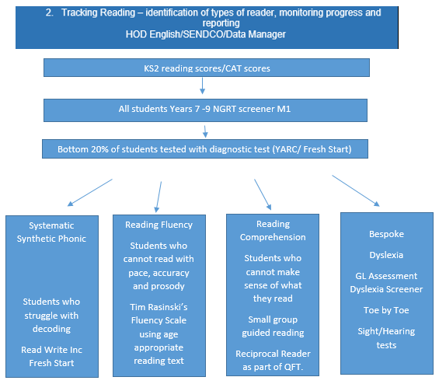
We are robust in our approach to identifying struggling readers. We screen our students immediately upon entry, identifying our bottom 20%. We follow up the screener with diagnostic testing – including phonics and dyslexia screeners and fluency and comprehension checkers, liaising with the SENCO and checking EHCPs.
We are forensic in our analysis of our data. We place students immediately on appropriate interventions, adopting a rolling timetable for this so that no students’ access to the curriculum is narrowed. We have regular assessment and tracking of performance schedule to ensure students graduate between and from interventions in a timely manner.



This will be a key focus for the academy for the academic year 23-24, with heads of department trained in instructional coaching by the Trust.

Curriculum staff adapt their lessons for struggling readers using evidence informed practices to ensure students can read in the different curriculum disciplines. Teaching staff at Belvoir have received training to support readers through generic reading strategies, which include:
- Understanding, approaching and breaking down Tier 2 and Tier 3 vocabulary (etymology and morphology, Freyer model)
- Reciprocal Reading metacognitive approaches to reading comprehension (predict, clarify, question and summarise)
- How students read and create meaning from their reading (Scarborough Reading Rope, Simple View of Reading, Arduous 8)
- A simplified 2 pronged approach (pre reading activity, such as a glossary for challenging words, and an opportunity for students to clarify other words they are unsure of after reading the text)
- Reading Fluency
- Echo and Choral Reading
- Text marking for fluency

These strategies are identified on the Priory Trust’s Language for Learning Framework, which we use to support our readers.
Spotlight students (students in the bottom 20% of KS3 students, as identified by NGRT testing) are identified on class registers. Students’ chronological reading ages and their standardised scores are on all class mark sheets for staff to plan to use generic reading strategies accordingly.
We also have a small group of trained Year 10 student reading mentors who work with identified Year 7 students on their reading fluency skills.

Our reading interventions are carried out by fully trained TAs, who maintain a fidelity to model.


