

The Priory Belvoir Academy
Safeguarding Team
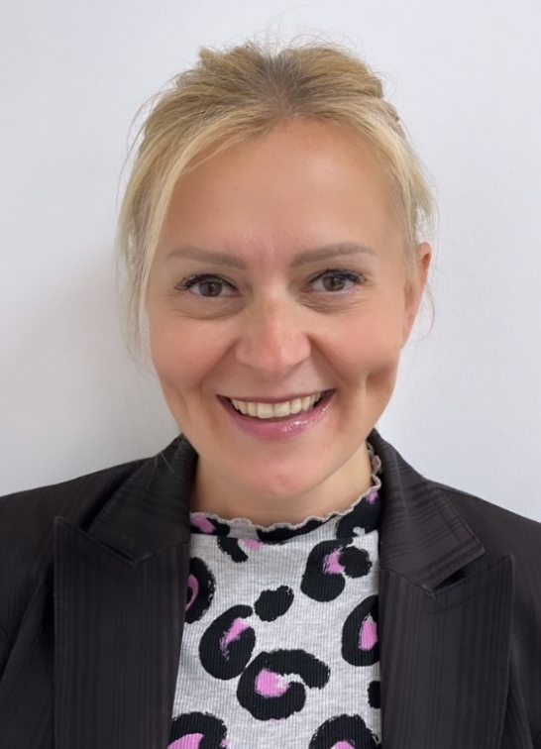


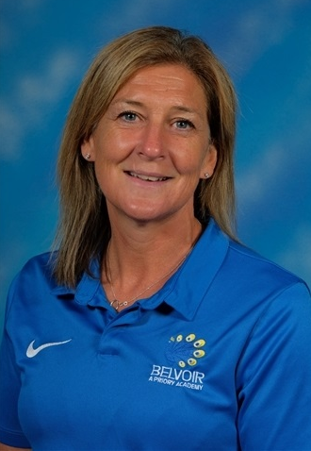
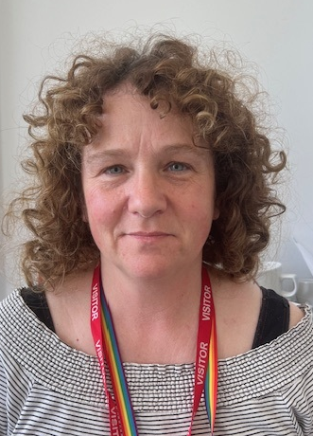
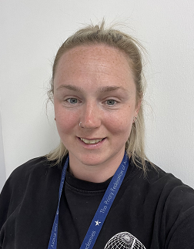
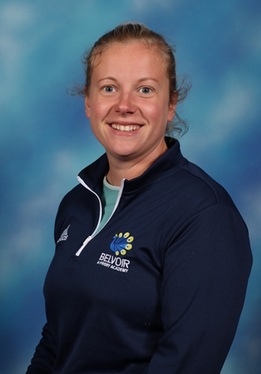
Don’t Worry if you are nervous to approach us with your concerns. You can make a disclosure using the following methods:
- Email us: BelvoirSG@prioryacademies.co.uk
- Microsoft forms (Academy Website -Safeguarding)
- Speak to any member of staff

Types of Safeguarding you can report:
- Sexual violence and Harassment
- Racism
- Homophobia and Transphobia
- Self-Harm and suicidal thoughts
- Drugs and Alcohol misuse
- Health issues
- Social media Misuse
- Child on child abuse
- Home Issues
Miss L Combes
Designated Safeguarding Officer, Deputy SENDCo & designated teacher of LAC/PLAC

Mrs M Ludlam
Designated Safeguarding Officer and Attendance manager
Mr J Miller
Designated Safeguarding Lead
Miss J Clegg
Designated Safeguarding Officer
Mrs D Bull
Deputy Safeguarding Lead
Mental Health Lead
Miss C Jones

